
Blast Off – Part #1 (Rocket Engine)

- Build the rocket part below by tracing the shape with your Evo
- Since Evo picks a random direction when it comes to a line intersection, you will need to use
Color Codes to tell it where to go
- Place a “Win and Stop” color code where the Evo will finish the shape
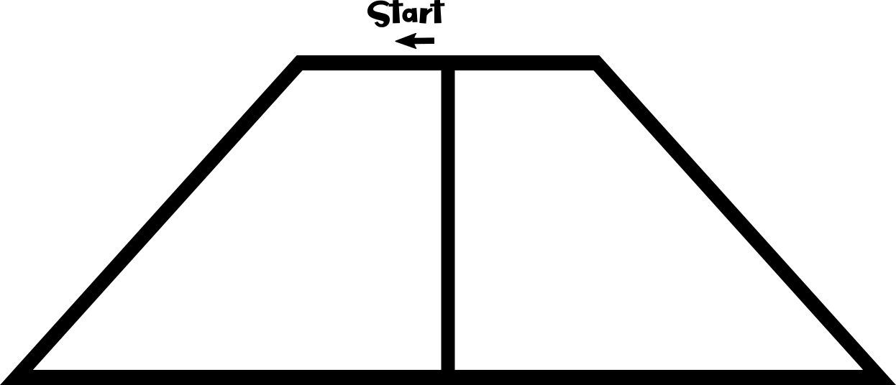

Blast Off – Part #2 (Fuselage)

- Build the rocket part below by tracing the shape with your Evo
- Since Evo picks a random direction when it comes to a line intersection, you will need to use
Color Codes to tell it where to go
- Place a “Win and Stop” color code where the Evo will finish the shape

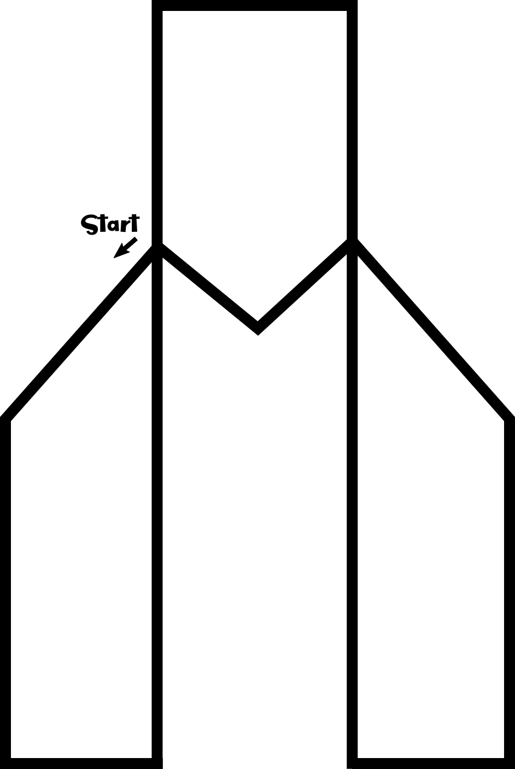

Blast Off – Part #3 (Nose Cone)

- Build the rocket part below by tracing the shape with your Evo
- Since Evo picks a random direction when it comes to a line intersection, you will need to use
Color Codes to tell it where to go
- Place a “Win and Stop” color code where the Evo will finish the shape
